Lab Work 1

Task 1.1 - Employee table
Employee(EmpID, SSN, Email, Phone, Name, Department, Salary)
Superkeys (6+):
- EmpID
- SSN
- Email
- EmpID + SSN
- EmpID + Name
- EmpID + Department
- SSN + Email
Candidate keys: EmpID, SSN, Email — these are the minimal ones, you can't remove anything from them and still have uniqueness.
Name and Phone are not candidate keys because they don't guarantee uniqueness.
Which one should be the primary key? I'd pick EmpID. SSN is sensitive info so you shouldn't really be using it as a key that gets copied into other tables as a foreign key everywhere. Email can also change if someone gets married or the company changes its email domain, so it's not very stable. EmpID is just a number the system generates and it never changes, so it makes the most sense.
Can two employees have the same phone number? Yeah, they can. Nothing says Phone has to be unique, so for example two people in the same department could be sharing one office phone. In the sample data they happen to be different but that doesn't mean they have to be.

Task 1.1 - Registration table
Registration(StudentID, CourseCode, Section, Semester, Year, Grade, Credits)
Rules given: a student can retake a course in a different semester, but can't register for the same section in the same semester twice.
Minimum PK: StudentID, CourseCode, Section, Semester, Year
Why we need all of these:
- StudentID - obviously need to know which student
- CourseCode - a student takes more than one course
- Section - same course can have multiple sections in one semester
- Semester and Year - because the same course can be retaken later, without these two the key wouldn't be unique for a repeated course
Grade and Credits are not part of the key, they just describe the registration/course, they don't help identify the row.
Other candidate keys? Not really, unless there's some kind of registration ID that isn't mentioned here.

Task 1.2 - University foreign keys
Student(StudentID, Name, Email, Major, AdvisorID)
Professor(ProfID, Name, Department, Salary)
Course(CourseID, Title, Credits, DepartmentCode)
Department(DeptCode, DeptName, Budget, ChairID)
Enrollment(StudentID, CourseID, Semester, Grade)
FKs:
- Student.AdvisorID -> Professor.ProfID
- Course.DepartmentCode -> Department.DeptCode
- Department.ChairID -> Professor.ProfID
- Enrollment.StudentID -> Student.StudentID
- Enrollment.CourseID -> Course.CourseID
PK of Enrollment is (StudentID, CourseID, Semester) since a student can take the same course again later.
One weird thing here - Professor and Department reference each other. Department has ChairID pointing to Professor, and professors work in a department. This is fine in relational databases but when you first insert data you might have to leave ChairID as NULL temporarily since you can't have a chair before you have any professors in that department.

Task 2.1 – Hospital Management System

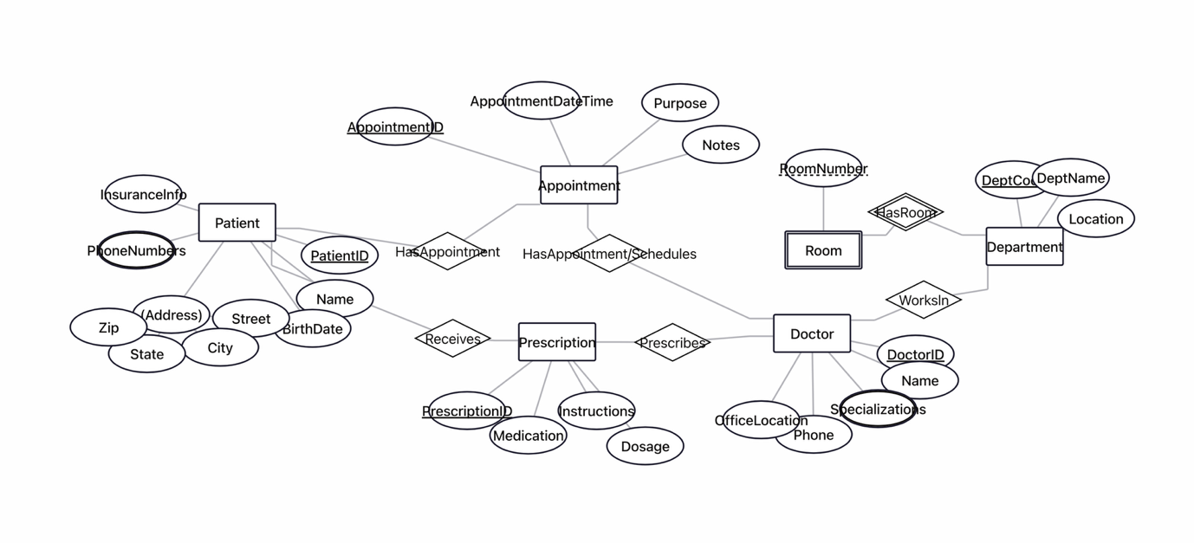

Task 2.2 – E -commerce Platform

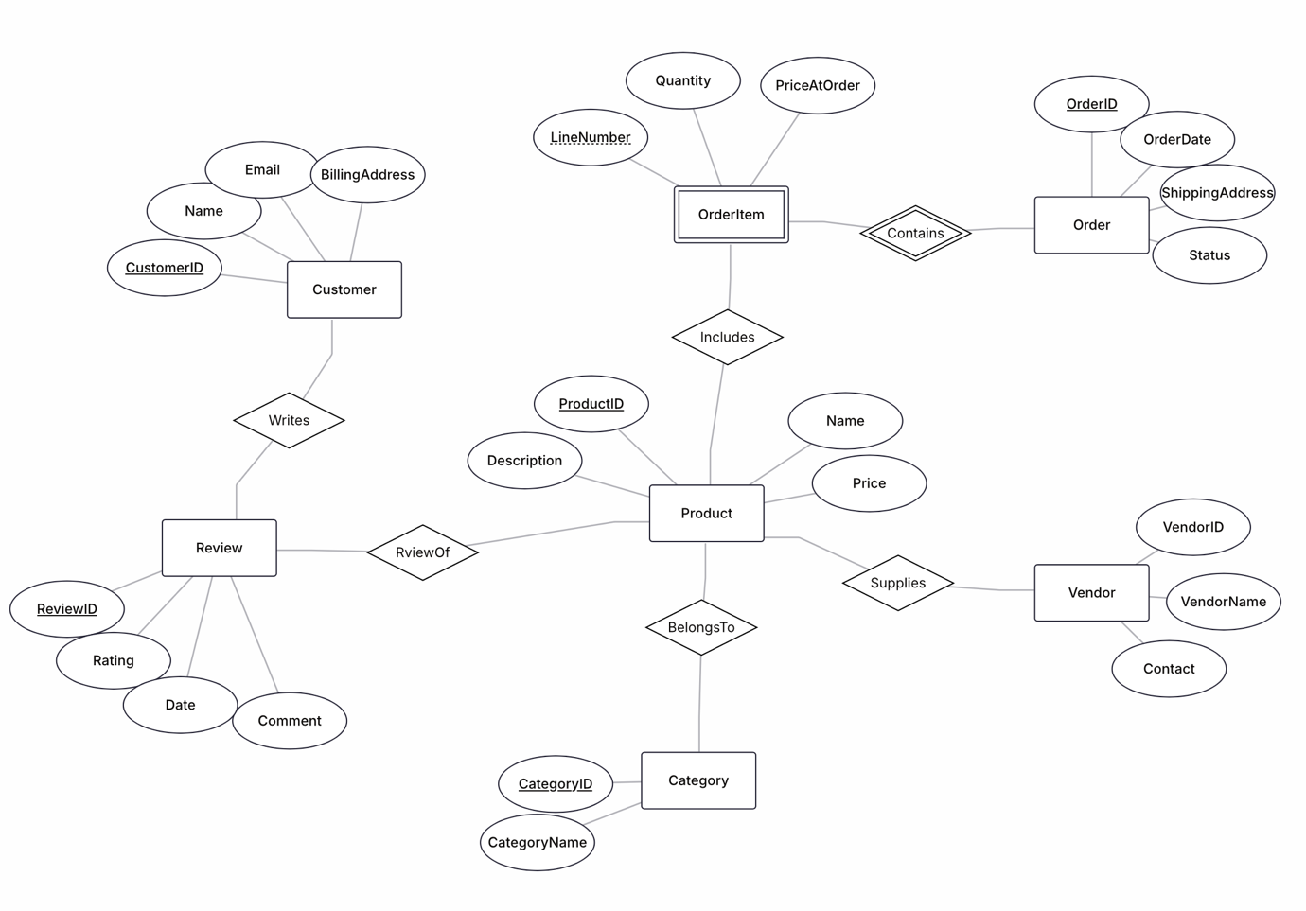

Task 5.1 – Real-World Application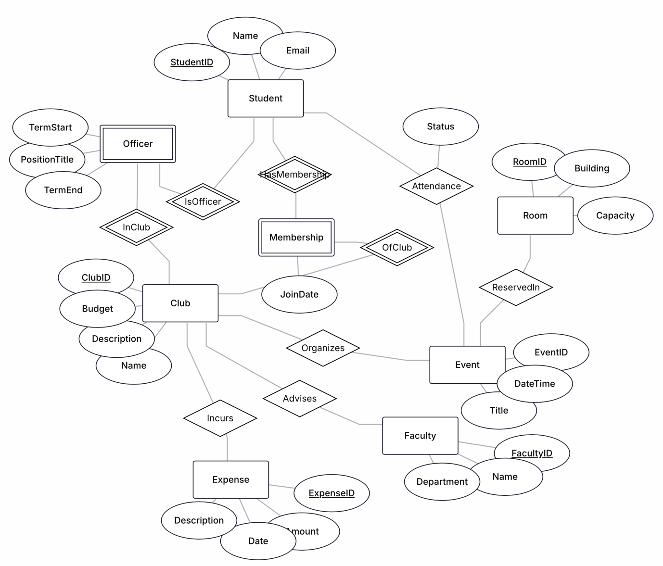

Task 4.1 - StudentProject table
StudentProject(StudentID, StudentName, StudentMajor, ProjectID, ProjectTitle,
ProjectType, SupervisorID, SupervisorName, SupervisorDept,
Role, HoursWorked, StartDate, EndDate)
FDs:
- StudentID -> StudentName, StudentMajor
- ProjectID -> ProjectTitle, ProjectType, SupervisorID
- SupervisorID -> SupervisorName, SupervisorDept
- StudentID, ProjectID -> Role, HoursWorked, StartDate, EndDate
Redundancy/anomalies:
Redundancy: if a student works on multiple projects, their name and major get repeated every time. Same with supervisor info - if a supervisor has multiple students, their name and department show up over and over.
Insert anomaly - you can't add a new supervisor unless they already have a student assigned to a project. There's no way to just add "here's a new supervisor" without a student-project row.
Update anomaly - if you fix a typo in a supervisor's name, you have to change it in every single row that mentions that supervisor, otherwise the data becomes inconsistent.
Delete anomaly - if a student's only project gets deleted, you lose that student's major info too, since it was only stored in that one row.
1NF: looks fine already, no repeating groups or multivalued columns in one cell.
2NF: PK is (StudentID, ProjectID).
Partial dependencies:
- StudentID -> StudentName, StudentMajor (only depends on part of the key)
- ProjectID -> ProjectTitle, ProjectType, SupervisorID, SupervisorName, SupervisorDept (only depends on part of the key)
Decompose:
Student(StudentID, StudentName, StudentMajor)
Project(ProjectID, ProjectTitle, ProjectType, SupervisorID, SupervisorName, SupervisorDept)
Assignment(StudentID, ProjectID, Role, HoursWorked, StartDate, EndDate)
3NF: In the Project table there's a transitive dependency: ProjectID -> SupervisorID -> SupervisorName, SupervisorDept. So SupervisorName/Dept depend on ProjectID only through SupervisorID, not directly.
Final tables:
Student(StudentID, StudentName, StudentMajor)
Supervisor(SupervisorID, SupervisorName, SupervisorDept)
Project(ProjectID, ProjectTitle, ProjectType, SupervisorID) -- FK to Supervisor
Assignment(StudentID, ProjectID, Role, HoursWorked, StartDate, EndDate) -- FKs to Student and Project

Task 4.2 - CourseSchedule table
CourseSchedule(StudentID, StudentMajor, CourseID, CourseName,
InstructorID, InstructorName, TimeSlot, Room, Building)
Primary key: this one's tricky because a student can be in many sections, and each section has many students, so it's really StudentID + CourseID.
FDs:
- StudentID -> StudentMajor
- CourseID -> CourseName, InstructorID, TimeSlot, Room
- InstructorID -> InstructorName
- Room -> Building
Is it in BCNF? No. For it to be BCNF, the left side of every FD needs to be a superkey, but:
- StudentID isn't a superkey by itself, yet it determines StudentMajor
- CourseID isn't a superkey by itself either, yet it determines a bunch of stuff
- Same problem with InstructorID and Room
So this table has a lot of problems, not even close to BCNF.
Decomposition:
Student(StudentID, StudentMajor)
Instructor(InstructorID, InstructorName)
Room(RoomID, Building)
CourseSection(CourseID, CourseName, InstructorID, TimeSlot, RoomID)
Enrollment(StudentID, CourseID)
Loss of information? Should be lossless since everything connects back through keys/FKs and you can reconstruct the original table by joining everything. The only thing to be careful about is the assumption that room numbers are unique campus-wide - if that wasn't true you'd need Building+RoomNumber together as the room's key instead of just RoomNumber.

